DALLAS MUZZLE LOADING GUN CLUB
Calling all
Colonialists, Longhunters, Buckskinners, & Mountain Men
30TH annual  pre-1840
FROZEN FOOT RENDEZVOUS
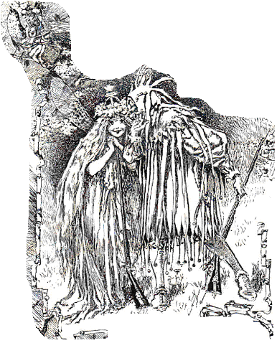
January 12, 13, & 14, 2018
Tool, Texas
THIS EVENT IS NOT OPEN TO THE GENERAL PUBLIC.
PRE-1840 DRESS IS REQUIRED  NO MODERN DRESS ALLOWED
FIRST PLACE AWARDS FOR EACH EVENT
AGGREGATE PRIZE BLANKET
Events: Rifle, Pistol must load from bag, Archery, Hawk, Knife, Fire starting.
We will have a cook contest - Booshway will provide main ingredient
A blanket prize is requested from each competitor.
Fees: Adults $15.00 Youth age 13 and younger $5.00 Medallions $ 5.00
Bring water. Some firewood is available.
For more information contact:
Debbie Williamson Booshway 214-577-7560 leave a message James Williamson Segundo 214-577-4176
We ask you to get your vehicle unloaded quickly as space is limited for other vehicles to get in camp. Please do not park on drive this just bottle necks the circle.
Looking forward to seeing old faces and new one.

